**Week 1 Assignment:**

**Design Patterns and Principles:**

**Exercise 1: Implementing the Singleton Pattern**

**Logger.java:**

public class Logger {  
 private static Logger *instance*;  
  
 private Logger() {  
 System.*out*.println("Logger constructor is initiated");  
 }  
  
 public static Logger getInstance() {  
 if (*instance* == null) {  
 *instance* = new Logger();  
 }  
 return *instance*;  
 }  
  
 public void getLog() {  
 System.*out*.println("Logging data...");  
 }  
}

**Main.java:**

//TIP To <b>Run</b> code, press <shortcut actionId="Run"/> or  
// click the <icon src="AllIcons.Actions.Execute"/> icon in the gutter.  
public class Main {  
 public static void main(String[] args) {  
 Logger log1 = Logger.*getInstance*();  
 Logger log2 = Logger.*getInstance*();  
  
 if (log1 == log2) {  
 System.*out*.println("log1 and log2 are the same instance");  
 } else {  
 System.*out*.println("log1 and log2 are not the same instance");  
 }  
 }  
}

**Output:**

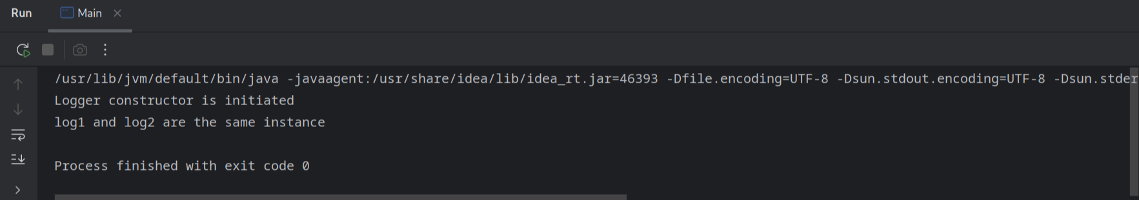

**Exercise 2: Implementing the Factory Method Pattern**

**Document.java:**

public interface Document {  
 public void getDocument();  
}

**WordDocument.java:**

public class WordDocument implements Document{  
 public void getDocument() {  
 System.*out*.println("This is a word document");  
 }  
}

**PdfDocument.java:**

public class PdfDocument implements Document{  
 public void getDocument() {  
 System.*out*.println("This is a pdf document");  
 }  
}

**ExcelDocument.java:**

public class ExcelDocument implements Document{  
 public void getDocument() {  
 System.*out*.println("This is an excel document");  
 }  
}

**DocumentFactory.java:**

public interface DocumentFactory {  
 public Document createDocument();  
}

**WordDocumentFactory:**

public class WordDocumentFactory implements DocumentFactory{  
 public Document createDocument() {  
 return new WordDocument();  
 }  
}

**PdfDocumentFactory:**

public class PdfDocumentFactory implements DocumentFactory{  
 public Document createDocument() {  
 return new PdfDocument();  
 }  
}

**ExcelDocumentFactory.java:**

public class ExcelDocumentFactory implements DocumentFactory{  
 public Document createDocument() {  
 return new ExcelDocument();  
 }  
}

**Main.java:**

//TIP To <b>Run</b> code, press <shortcut actionId="Run"/> or  
// click the <icon src="AllIcons.Actions.Execute"/> icon in the gutter.  
public class Main {  
 public static void main(String[] args) {  
 DocumentFactory pdfFactory = new PdfDocumentFactory();  
 DocumentFactory wordFactory = new WordDocumentFactory();  
 DocumentFactory excelFactory = new ExcelDocumentFactory();  
  
 Document pdf = pdfFactory.createDocument();  
 Document word = wordFactory.createDocument();  
 Document excel = excelFactory.createDocument();  
  
 pdf.getDocument();  
 word.getDocument();  
 excel.getDocument();  
 }  
}

**Output:**

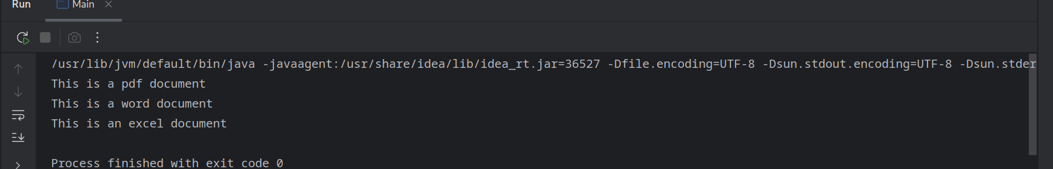

**Data Structures and Algorithms:**

**Excercise 2: E-commerce Platform Search Function**

**Product.java:**

import java.util.ArrayList;  
import java.util.List;  
  
public class Product {  
 private List<String> productId;  
 private List<String> productName;  
 private List<String> category;  
  
 Product(List<String> productId, List<String> productName, List<String> category) {  
 this.productId = productId;  
 this.productName = productName;  
 this.category = category;  
 }  
  
 public int searchProductId(String key) {  
 return Search.*linearSearch*(productId, key);  
 }  
  
 public int searchProductName(String key) {  
 return Search.*binarySearch*(productName, key);  
 }  
  
 public int searchCategory(String key) {  
 return Search.*binarySearch*(category, key);  
 }  
}

**Search.java:**

import java.util.List;  
  
public class Search {  
 public static int linearSearch(List<String> array, String key) {  
 for (int i=0; i<array.size(); i++) {  
 if (array.get(i) == key) {  
 return i;  
 }  
 }  
 return -1;  
 }  
  
 public static int binarySearch(List<String> array, String key) {  
 int left = 0, right = array.size()-1;  
 while (left <= right) {  
 int mid = left + (right - left) / 2;  
 int compare = array.get(mid).compareTo(key);  
 if (compare == 0) {  
 return mid;  
 } else if (compare > 0) {  
 right = mid - 1;  
 } else {  
 left = mid + 1;  
 }  
 }  
 return -1;  
 }  
}

**Main.java:**

import java.util.ArrayList;  
import java.util.List;  
  
//TIP To <b>Run</b> code, press <shortcut actionId="Run"/> or  
// click the <icon src="AllIcons.Actions.Execute"/> icon in the gutter.  
public class Main {  
 public static void main(String[] args) {  
 List<String> productId = new ArrayList<>();  
 List<String> productName = new ArrayList<>();  
 List<String> category = new ArrayList<>();  
  
 productId.add("P001");  
 productId.add("P002");  
 productId.add("P003");  
  
 productName.add("aaa");  
 productName.add("bbb");  
 productName.add("ccc");  
  
 category.add("xxx");  
 category.add("yyy");  
 category.add("zzz");  
  
 Product p = new Product(productId, productName, category);  
 System.*out*.println(p.searchProductId("P002"));  
 System.*out*.println(p.searchProductName("aaa"));  
 System.*out*.println(p.searchCategory("zzz"));  
 }  
}

**Output:**

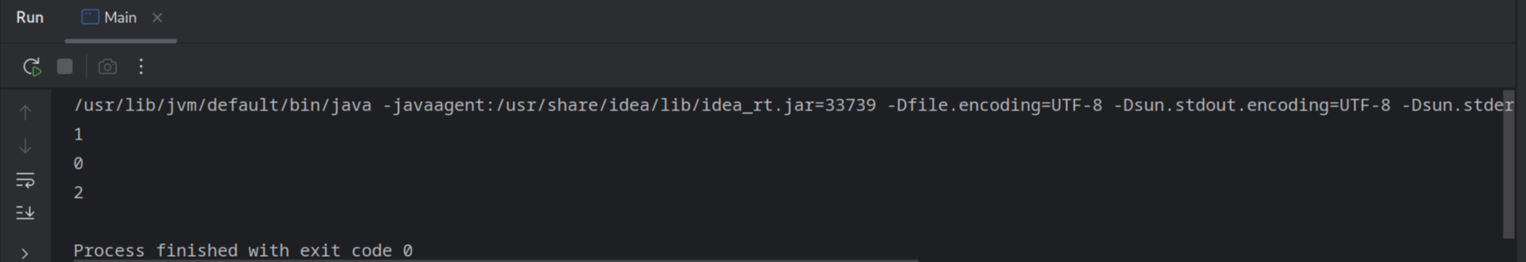

**Exercise 7: Financial Forecasting**

**Predictor.java:**

public class Predictor {  
  
 private final double RATE = 0.05;  
 private double principalAmount;  
  
 Predictor(int principalAmount) {  
 this.principalAmount = principalAmount;  
 }  
  
 public double getAmount(int years) {  
 if (years == 0) {  
 return principalAmount;  
 }  
 return getAmount(years - 1) * (1 + RATE);  
 }  
}

**Main.java:**

//TIP To <b>Run</b> code, press <shortcut actionId="Run"/> or  
// click the <icon src="AllIcons.Actions.Execute"/> icon in the gutter.  
public class Main {  
 public static void main(String[] args) {  
 Predictor p = new Predictor(10000);  
 System.*out*.println(p.getAmount(3));  
 }  
}

**Output:**

